Fishing Guide

When was the last time you heard someone boast about the trophy large mouth bass they reeled in on their last fishing outing? Have you always wanted to go fishing but didn’t know where to start? Whether you assume this popular sport is as easy as finding a pond and plopping yourself down with a line, or whether you are intimidated by the large array of rods, reels, baits, lures and fish, these few basic guidelines will help you get started.

The choices in the world of fishing are enormous. Do you want to fish for fun, for trophy or for supper? Are you looking for a particular type of fish or for the most convenient location? Are you handy with a boat or more comfortable sticking to shore?

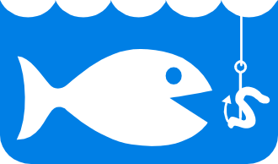No matter what your preferences are, try to choose a quiet location in the cool still of the early morning or evening. Make sure you are aware of the weather forecast before you set out so you can dress appropriately. Remember

what temperatures are often cooler by the water, with different wind factors. Don’t be discouraged by light rain since some of the best fishing can be done in the rain! And don’t forget to pack plenty to eat for an enjoyable outing.

Some good guides to fishing spots in your area can be obtained from local tourism information.

